**DATA VISUALIZATION PROJECT REPORT**

**(**Project Semester August-December 2024)

***Mapping the Future of Mobility: EV Charging Patterns and***

***Usage Trends***

Submitted by

Name: Chundru Rishith Sai Chowdary

Registration number: 12212330

Programme: B.Tech. (Computer Science and Engineering)

Section: K22BW

Course Code: INT233

Under the Guidance of

**Name: Vikas Mangotra**

**U.ID: 31488**

**Discipline of CSE/IT**

**Lovely School of Computer Science and Engineering**

**Lovely Professional University, Phagwara**

**DECLARATION**

I, Chundru Rishith Sai Chowdary, student of B.Tech under CSE/IT Discipline, at Lovely Professional University, Punjab. I hereby declare that all the information furnished in this project report is based on my own intensive work and is genuine.

Date: 15-11-2024 Signature

Registration No: 12212330 Chundru Rishith Sai Chowdary

**ACKNOWLEDGMENT**

I would like to extend my gratitude to Vikas Mangotra Sir, for their guidance, support, and encouragement throughout this project. This report is the result of collaborative efforts and insights gained from my faculty member.

**TABLE OF CONTENTS**

**INTRODUCTION**

In recent years, electric vehicles (EVs) have grown in popularity as more people and companies seek sustainable alternatives to traditional gas-powered cars. EVs offer several advantages, such as lower emissions, reduced fuel costs, and quieter operation. However, as EV use has increased, so has the need for effective charging infrastructure to support these vehicles on the road. EV charging stations are essential in helping drivers maintain their vehicles’ battery levels during daily use, long journeys, and especially in areas with fewer residential charging options.

This project analyses patterns in EV charging behaviour to gain insight into how, when, and where drivers are charging their vehicles. By understanding these patterns, we can learn more about peak times for charging, the costs involved, and how different factors like temperature and vehicle type influence charging needs. This data is valuable for a wide range of stakeholders, including city planners, EV manufacturers, and charging station operators. For instance, cities can use this information to identify areas where more charging stations might be needed, and manufacturers can use it to improve battery life and charging speed.

Using a dataset that records details like charging station ID, charging times, costs, energy consumed, and user demographics, this project aims to uncover patterns that reveal how charging habits vary by location, vehicle model, weather, and more. The results will help paint a clearer picture of the current EV charging landscape and suggest ways to make charging more accessible, efficient, and cost-effective for everyone.

The analysis was conducted in Tableau, a powerful visualization tool, to create clear and interactive dashboards that highlight key insights. This project will guide future decisions in building a sustainable charging network that supports the growing number of EVs on the road.

**SCOPE OF ANALYSIS**

The scope of this project is to analyse diverse factors that impact electric vehicle (EV) charging patterns, aiming to uncover insights that can support efficient infrastructure planning and enhance user experience. This analysis covers several dimensions of EV charging behaviour including:

1. **Charging Time and Duration**: By examining when drivers charge their vehicles and how long each session lasts, we can identify peak charging hours and determine the demand on charging infrastructure throughout the day. This helps in understanding if existing stations meet user needs or if more stations are required during peak hours.
2. **Energy Consumption and Charging Cost**: Investigating the relationship between energy consumed and associated costs helps identify trends in charging expenses. This data could also reveal if certain times or conditions result in higher costs, providing opportunities for users to save on charging and for providers to manage pricing models effectively.
3. **Environmental Factors**: The impact of external conditions, such as temperature, on charging efficiency and battery performance is analysed to determine how weather variations affect EV charging needs. This understanding can inform station design in diverse climates and help anticipate seasonal demand changes.
4. **Geographic Distribution and Location Insights**: Analysing charging station locations provides insights into which areas experience the most activity, helping to identify potential EV charging deserts or oversaturated areas. This spatial analysis is crucial for making data-driven decisions in expanding the EV charging network where it is most needed.
5. **Technology and Charger Types**: Examining the usage of various charger types (e.g., fast chargers vs. standard chargers) helps understand user preferences and the demand for quicker charging solutions. Insights here can guide providers on where to install faster chargers to better serve high-demand locations.

This analysis aims to serve EV manufacturers, city planners, energy providers, and policy makers by providing actionable insights into optimizing the EV charging network for a growing user base.

**OBJECTIVES**

The objective of the first visualization is to display the total energy consumed by each vehicle model in a clear, sequential manner using a waterfall chart. This method highlights the cumulative effect of each vehicle's energy consumption, emphasizing both positive and negative changes in the dataset, and makes it easier to compare the overall energy usage across different vehicle models. The second visualization compares the relationship between the average distance driven and the average charging rate for each vehicle model, helping to visualize trends or correlations between distance and charging efficiency. The third visualization visually represents the geographic distribution of energy consumption by electric vehicles at various charging station locations, identifying regional patterns in energy usage and offering insights into areas with higher or lower energy demand for charging. The fourth visualization presents a focused view of specific measures from the dataset, selecting and filtering particular measures to provide clarity on the most relevant metrics for decision-making. The fifth visualization shows the trend of average charging costs across different charging station locations, offering valuable insights for users and station operators regarding pricing strategies and cost trends. The sixth visualization compares total charging duration and charging rate for each charging station location, using a dual-bar format with a calculated midpoint to highlight differences between the two measures and offering a visual comparison of charging efficiency versus time.

The seventh visualization displays the proportion of total distance driven by each vehicle model using a pie chart, emphasizing each model's contribution to the overall distance driven. This makes it easier to compare vehicle usage across models. The eighth visualization shows the average vehicle age for each vehicle model, providing insights into fleet composition, usage, and potential maintenance needs. The ninth visualization visualizes the total charging cost for each vehicle model using a funnel chart, highlighting how charging costs fluctuate across different models. By using a negative sum for one of the values, it illustrates cost efficiency and changes in overall charging costs. The tenth visualization compares the charging start and end percentages for each vehicle model, allowing both measures to be visualized on the same chart. This demonstrates how the two percentages vary together, offering insights into charging behaviour and efficiency for different vehicle models.

The eleventh visualization aims to display the average battery capacity for each vehicle model, highlighting trends in battery capacity across models. This chart offers a clear representation of how battery capacity differs among vehicle models, providing valuable insights into charging requirements and efficiency. Together, these visualizations present a comprehensive analysis of electric vehicle data, helping to better understand key metrics such as energy consumption, charging behaviour, and vehicle characteristics, while also providing insights that can guide decision-making in fleet management and energy optimization.

**METHODOLOGY**

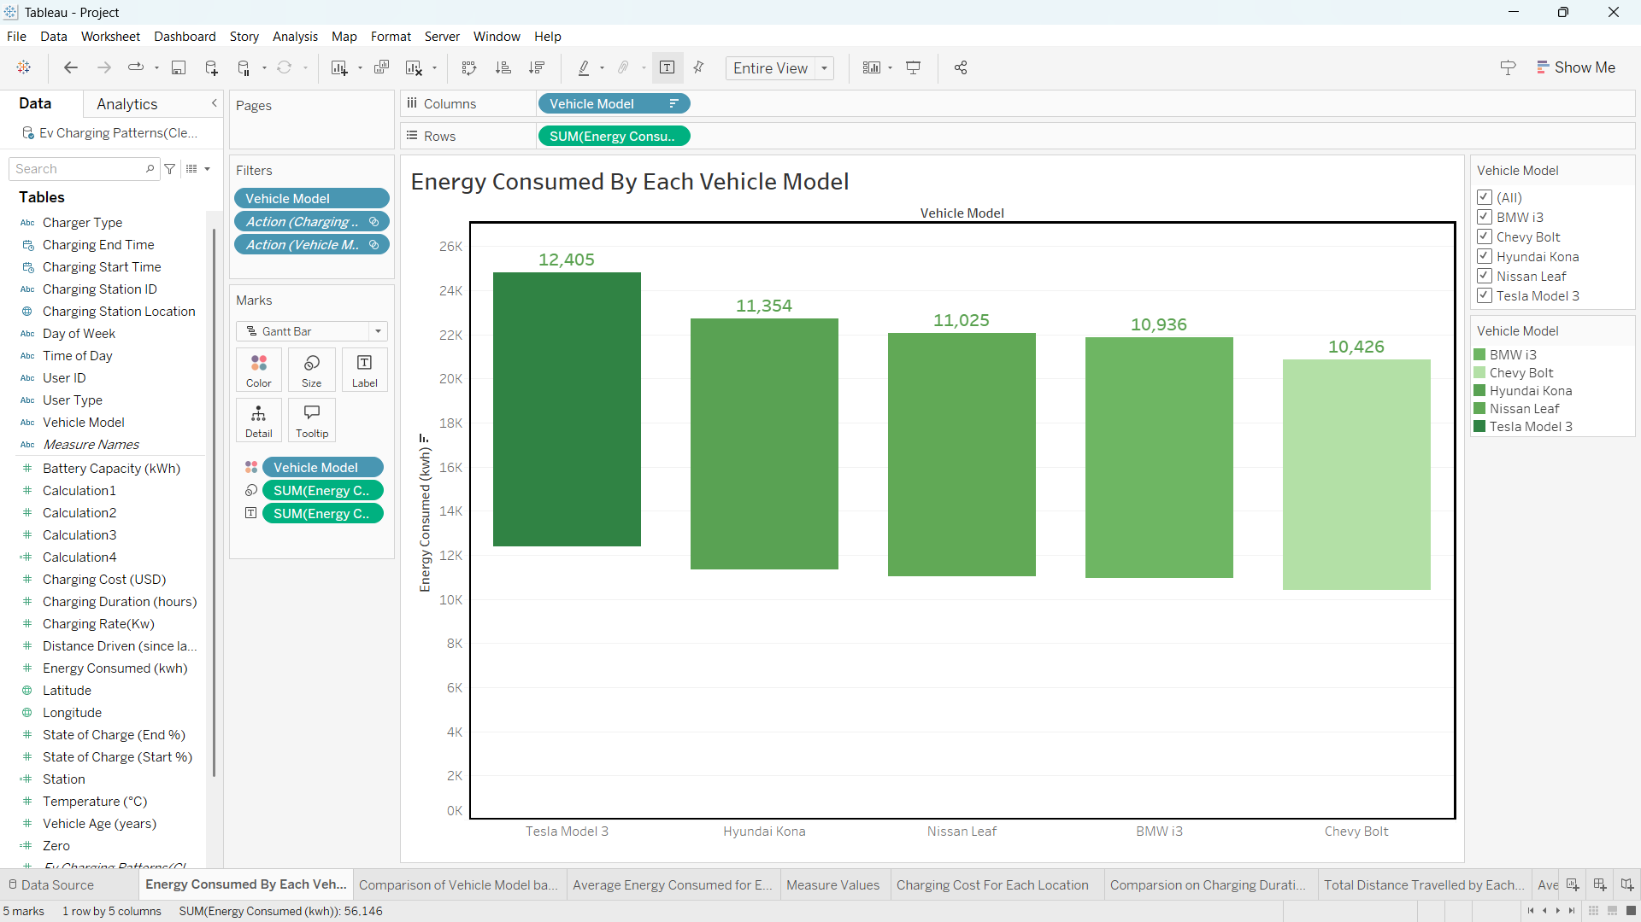  
Fig: 3.1 - Total Energy Consumed by Each Vehicle Model

* **Fig 3.1** shows a waterfall chart displaying the total energy consumed by each vehicle model. To create this chart, I placed *Vehicle Model* in the columns field and *Sum of Energy Consumed* in the rows field. Then, I changed the chart type to Gantt Bar and adjusted the *Size* field with *Energy Consumed* to achieve the waterfall effect.

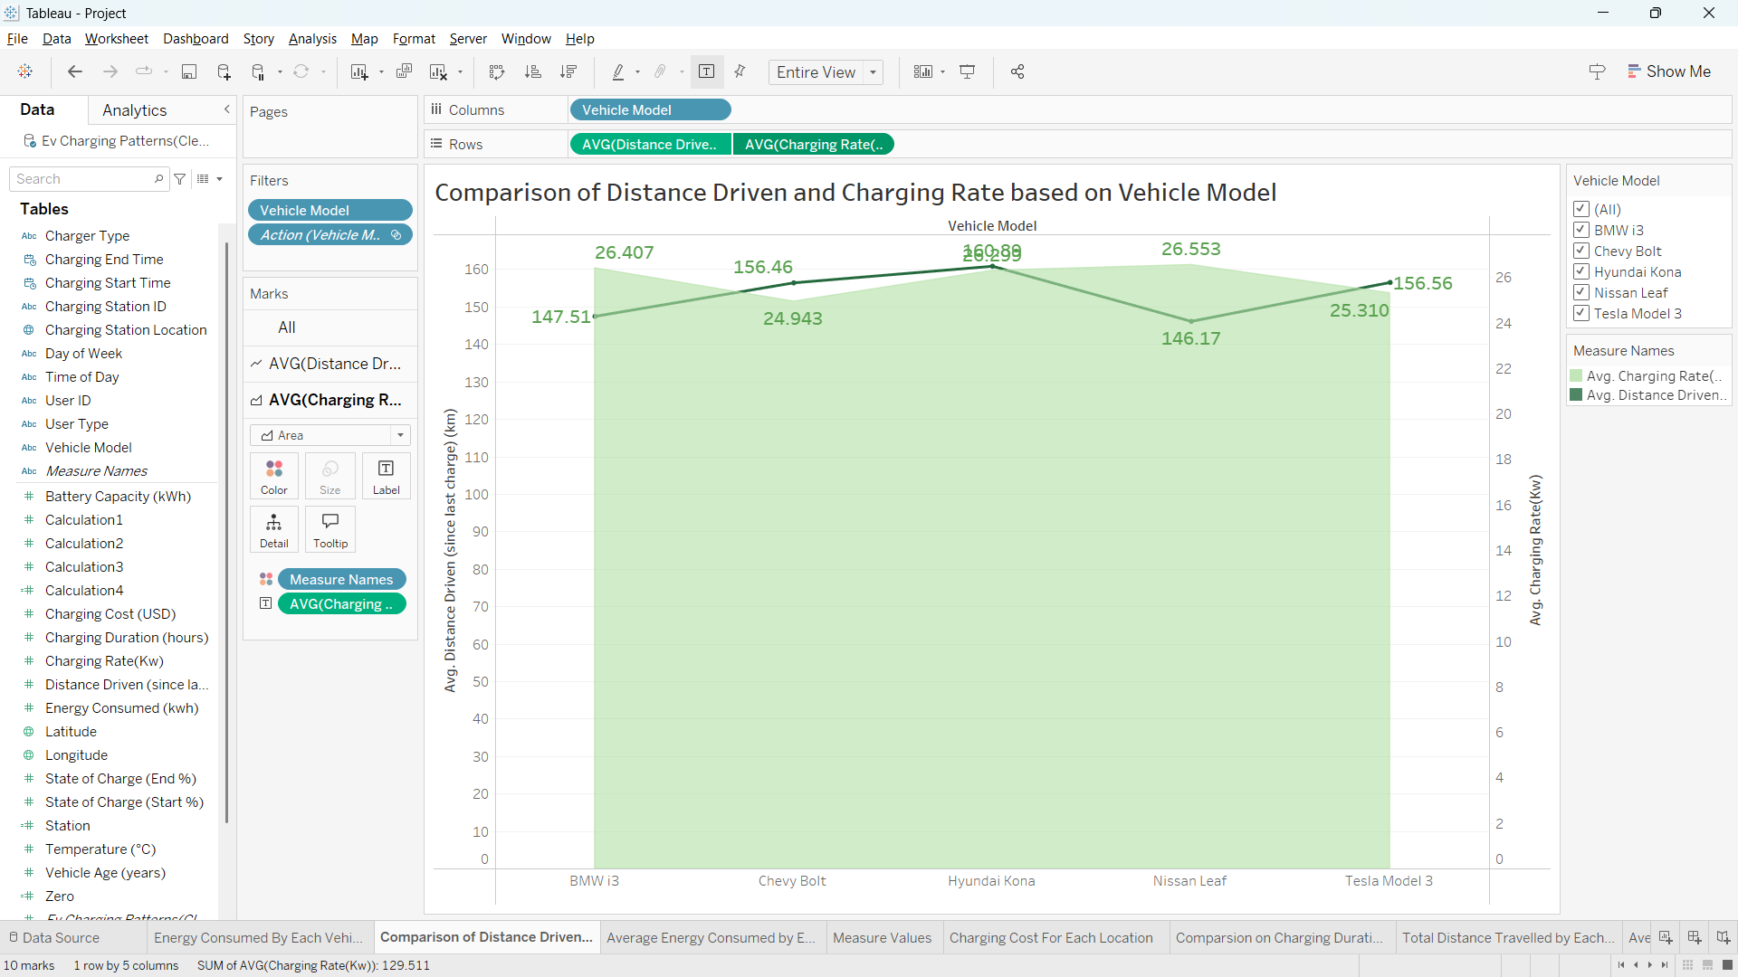

Fig: 3.2 - Comparison of Distance Driven and Charging Rate based on Vehicle Model

* **Fig 3.2** shows a dual-axis chart comparing the average distance driven and the average charging rate for each vehicle model. To create this chart, I placed *Vehicle Model* in the columns field and *Average Distance Driven* and *Average Charging Rate* in the rows field. Then, I selected the dropdown on one of the rows to enable dual axis, formatting one as an area chart and the other as a line chart.

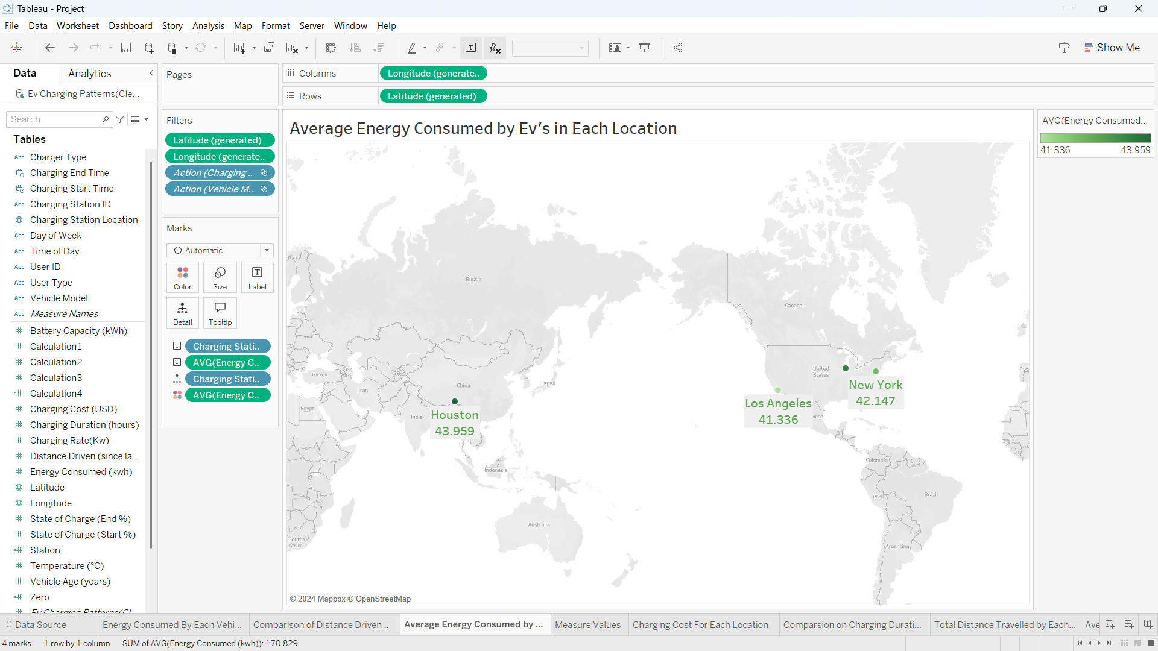

Fig: 3.3 - Average Energy Consumed by Ev’s in Each Location

* **Figure 3.3** shows a map chart displaying the average energy consumed by electric vehicles at each charging station location. To create this chart, I used *Charging Station Location*, a geographical data type, which enabled the map visualization. I then labelled each point with *Charging Station Location* and *Average Energy Consumed* and selected the map chart option from the "Show Me" panel.

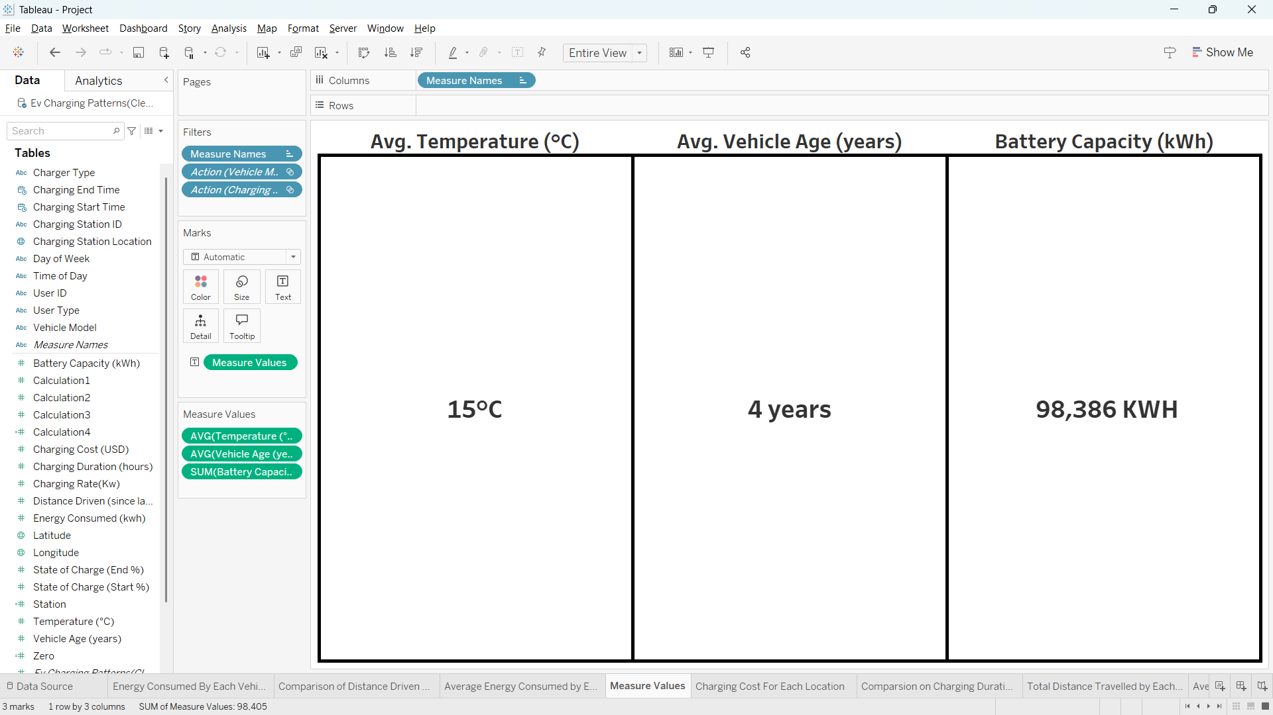

Fig: 3.4 – Measure values

* **Fig 3.4** displays selected measure values from the dataset. To create this visualization, I added the *Measure Values* field and filtered specific measures to showcase in the dashboard. I then formatted the chart for enhanced visual clarity.

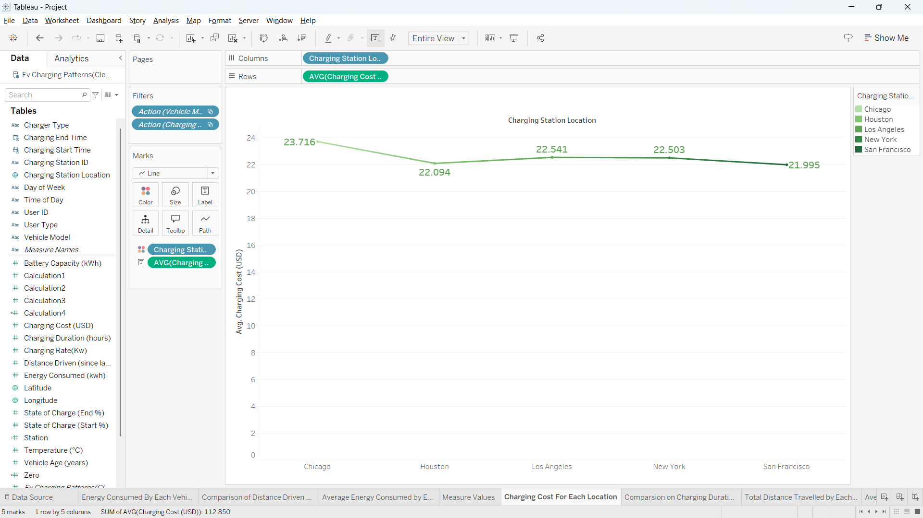

Fig: 3.5 - Average Charging Cost for Each Location

* **Fig 3.5** shows a line chart displaying the average charging cost for each charging station location. To create this chart, I placed *Charging Station Location* in the columns field and *Average Charging Cost* in the rows field. I then labelled the chart with *Charging Cost* and selected the line chart option from the "Show Me" panel.

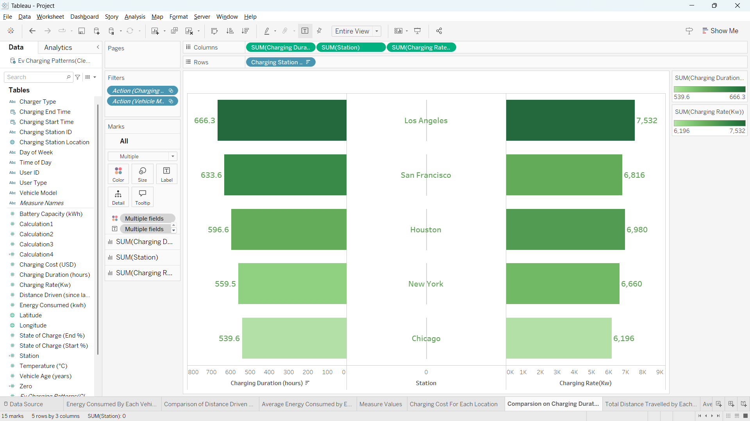

Fig: 3.6 – Comparison on Total Charging Duration and Charging Rate for Each Location

* **Figure 3.6** shows a butterfly chart comparing the total charging duration and charging rate for each location. To create this chart, I placed *Charging Duration* and *Charging Rate* in the columns field and created a calculated field set to zero, positioning it between the two measures to serve as the midpoint. I added *Charging Station Location* in the rows field, then formatted *Charging Duration* and *Charging Rate* as bar charts to create the butterfly effect.

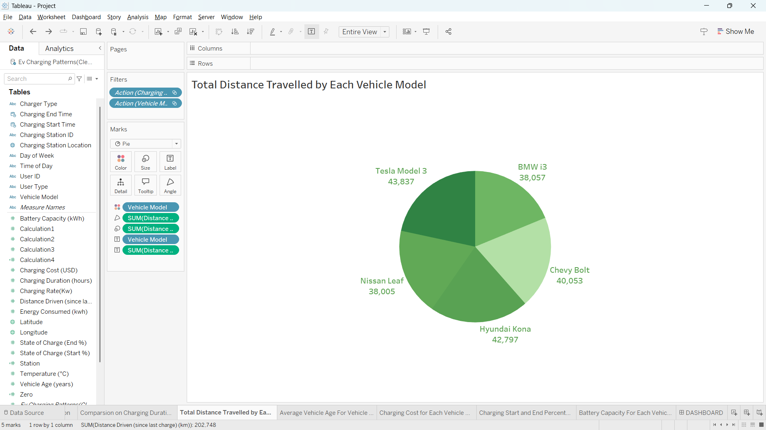

Fig: 3.7 – Total Distance Travelled by each Vehicle Model

* **Figure 3.7** shows a pie chart displaying the total distance driven by each vehicle model. To create this chart, I placed *Vehicle Model* in the labels field and used *Total Distance driven* as the measure. I then selected the pie chart option from the "Show Me" panel and formatted the chart to clearly represent the distance contribution of each vehicle model.

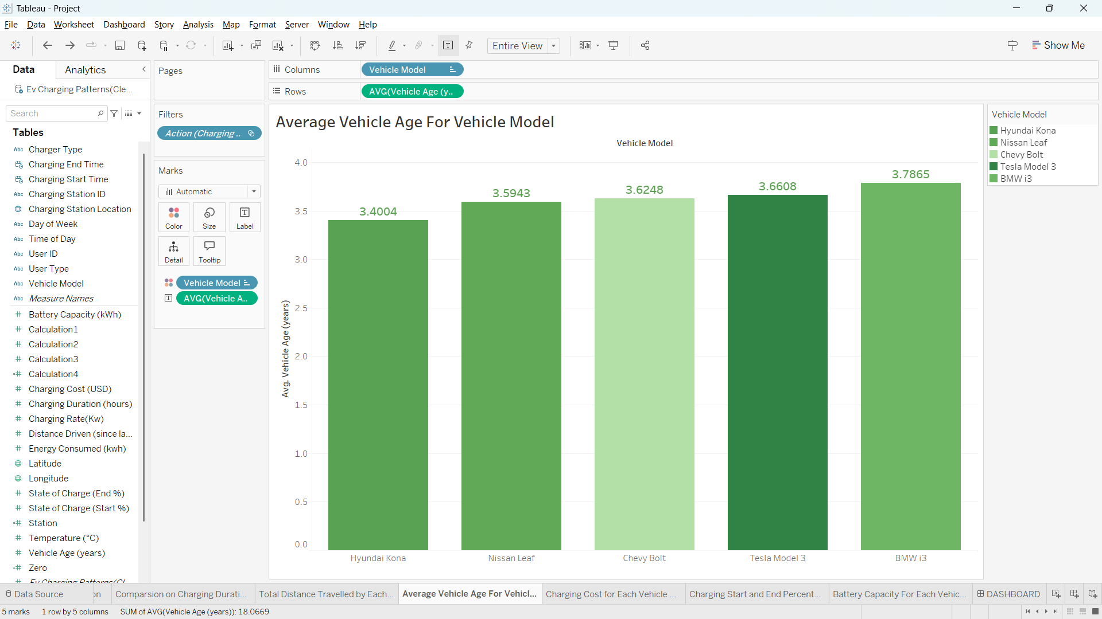

Fig: 3.8 – Average Vehicle Age for Each Vehicle Model

* **Fig 3.8** shows a bar chart displaying the average vehicle age for each vehicle model. To create this chart, I placed *Vehicle model* in the columns field and *Average vehicle age in* the rows field. I then labelled the chart with *average vehicle age* and selected the bar chart option from the "Show Me" panel.

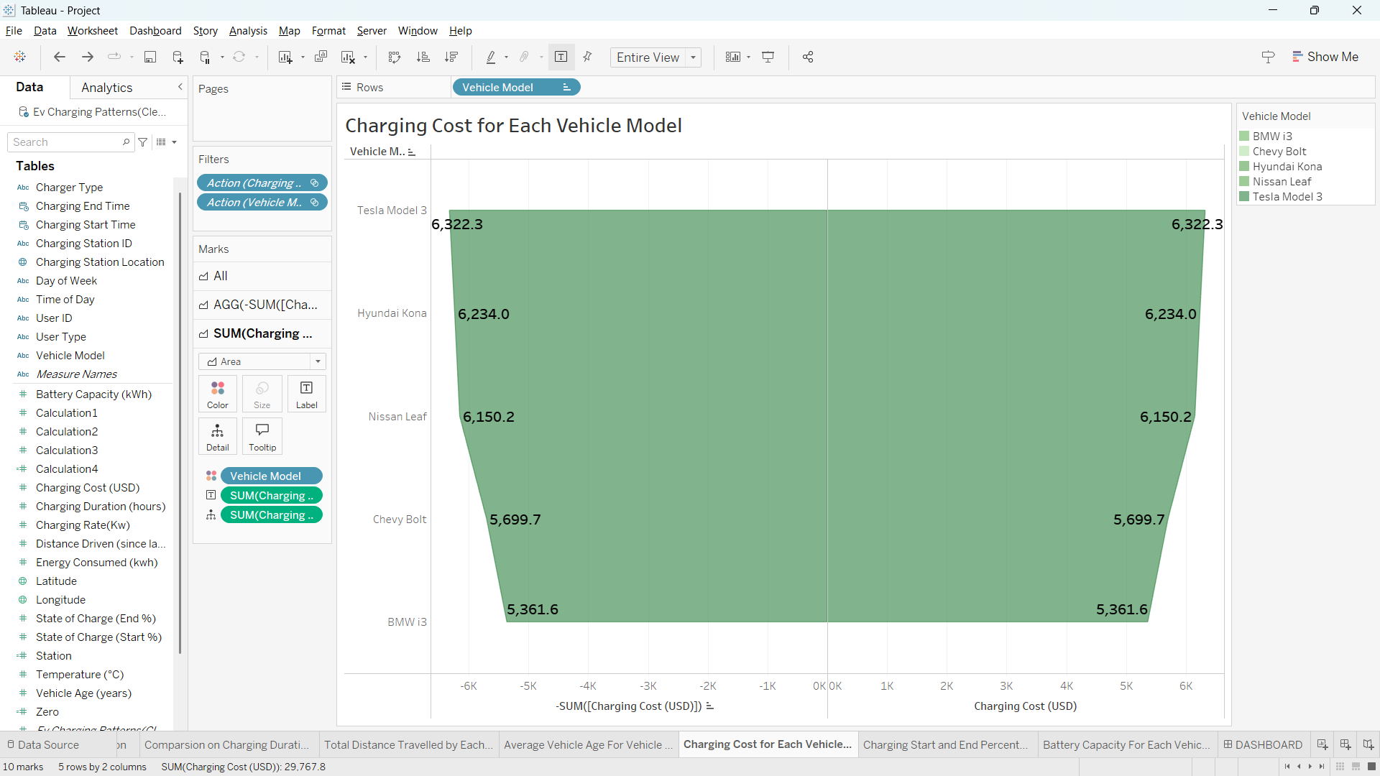

Fig: 3.9 - Charging Cost for Each Vehicle Model

* **Fig 3.9** shows an advanced funnel chart displaying the total charging cost for each vehicle model. To create this chart, I placed two instances of *Sum of Charging Cost* in the columns field, setting one of them as a negative sum. I added *Vehicle Model* in the rows field and selected the area chart option to create the funnel effect.

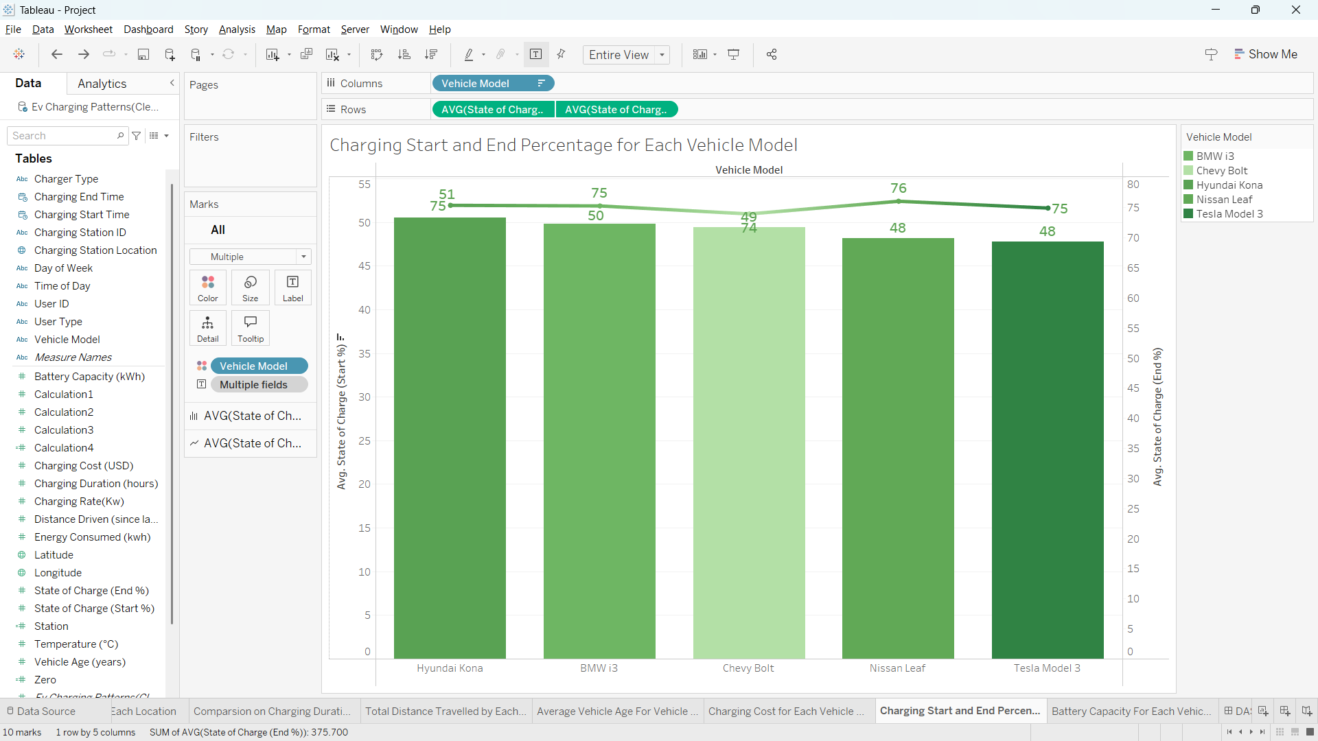

Fig: 3.10 – Average Charging Start Percentage and End Percentage of Each vehicle Model

* **Fig 3.10** shows a dual-axis chart comparing the average charging start and end percentage for each vehicle model. To create this chart, I placed *Vehicle Model* in the columns field and *Average Charging Start Percentage* and *Average Charging End Percentage* in the rows field. I then selected the dropdown menu on one of the rows to enable the dual-axis feature, formatting one as a bar chart and the other as a line chart.

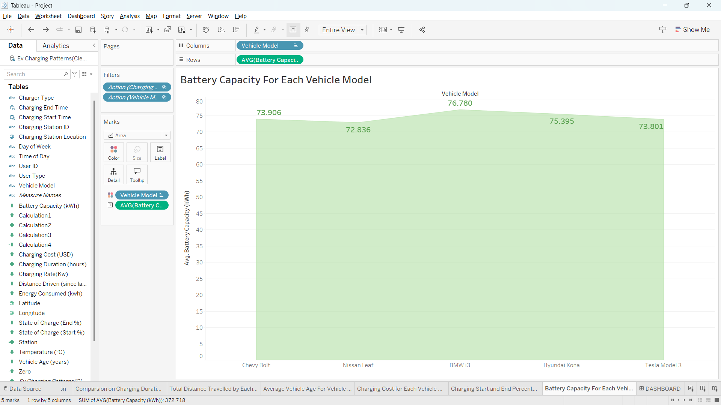

Fig: 3.11 – Average Battery Capacity for Each Vehicle Model

* Fig 3.11 shows an area chart displaying an Average battery capacity for each vehicle model. To create this chart, I have placed *vehicle model* in columns field and *average battery capacity* in row field. And I have selected area chart from show me panel.

**EXISTING SYSTEM**

The traditional approach to understanding EV charging behaviour involves limited data from surveys and select locations. Key limitations include:

* Data Availability: Traditional systems rely on fragmented or incomplete data.
* Real-time Analysis: Lack of access to dynamic and comprehensive datasets limits timely insights.

**SOURCE OF DATASET**

This Dataset is extracted from Kaggle.

Dataset Link: <https://www.kaggle.com/datasets/valakhorasani/electric-vehicle-charging-patterns>

**ETL PROCESS**

The ETL process involved:

* Data Extraction: The data is Extracted from Kaggle.
* Data Transformation: Cleaning, handling null values, and converting formats for compatibility.
* Data Loading: Importing transformed data into Tableau for visualization.